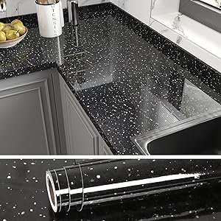

$7

VEELIKE Black Galaxy Granite Contact Paper for Countertops Waterproof Peel and Stick Countertops for Kitchen Black Marble Wallpaper 15.7''x118'' Self Adhesive Counter Vinyl for Bathroom Table Walls